**Introduction**

One of the main hypotheses for high (tropical) plant diversity is pollinator-driven plant speciation; pollinator shifts are responsible for approximately one quarter of divergence events in plants (van de Neit and Johnson (2012). Access to pollinators limit plant reproductive success through pollen limitation and heterospecific pollen transfer. In diverse tropical assemblages, the high number of congeneric species may lead to competition for pollinator visitation. Closely related plants can minimize pollinator overlap by evolving advantageous morphology to promote pollinator fidelity. Additionally, plants can minimize pollinator overlap through flowering phenology in time and space. We analyzed hummingbird visited Gesneriaceae from the cloud forests of Northwest Ecuador to investigate whether 1) closely related species differ in hummingbird visitors, 2) morphological differentiation leads to reduced visitor overlap, 3) species that share hummingbird visitors bloom at different times of year.

*Background on niche differentiation and pollination ecology*

A high number of co-occurring species may lead to reduced fitness though competition for pollinator visitation. Access to pollinators influences plant reproductive success through pollen limitation and heterospecific pollen transfer (e.g., Feinsinger and Tiebout 1991 or reviewed by XX). For related species, this fitness cost can be particularly high because of the possibility of inviable or lower fitness offspring (cite). Closely related plants can minimize pollinator overlap by evolving morphology to promote pollinator fidelity and adjusting their flowering phenology to reduce overlap in blooming with closely related species.

* Niche differentiation – i.e., pollinator niche (from the plant’s perspective), evolution of niche differentiation?
* Different flower morphologies attract different pollinators and/or deposit pollen in distinct parts of the pollinator’s body (i.e., flower resupination).
* Species can flower at different times of the year (I wonder if this is more common in tropical systems where you have the potential for year-round flowering)
* Hummingbird foraging behavior, trait matching

*Background on system/study site*

* Gesneriaceae in our study site vary in morphological and color characteristics suggesting that different species may be pollinated by different hummingbirds.
* Hummingbirds in our site vary in morphological characteristics (ordination of trait space) that may be linked to flower preference and behavior (trap-lining etc).
* Trait-matching between corolla and bill length persistent across the year

*Hypotheses*

H1: Closely related plant species avoid pollinator competition by blooming at different times in the year.

H2: Closely related species that bloom at the same time have different hummingbird pollinators where differentiation in flower characteristics leads to reduced visitor overlap

**Data** from Maquipucuna and Santa Lucia (~ 0.13, -78.63):

*Plant Species*

* *Glossoloma oblongicalyx*
* *Glossoloma purpureum*
* *Kohleria affinis*
* *Columnea ciliata*
* *Columnea medicinalis*
* *Columnea strigosa*
* *Columnea mastersonii (cinerea?)*
* *Columnea picta*
* *Columnea kucyniakii*
* *Besleria solanoides*
* *Gasteranthus lateralis*
* *Gasteranthus quitensis*
* *Drymonia collegarum*
* *Drymonia tenuis*
* *Drymonia teuscheri*

*Plant traits*

Flowers of these species were characterized using nine morphological traits reflecting their variation in size, shape and color (electronic supplementary material, table S2). Serrano-Serrano *et al. 2017* [discuss availability and appropriateness of these traits, i.e., not all species at our site in this table, additional traits needed?]

**Table S2.** Functional groups of pollinator, source of observation, and flower traits for 118 Gesnerioideae species from tropical America. Trait were coded as follows: **1.** Length of the corolla (mm). **2.** Corolla width at the mouth (mm), **3.** Ratio between the diameter at mouth and the length of the corolla (proxy of shape). **4.** Corolla shape (1) campanulate, (2) funnel, (3) tubular. **5.** Pistil/stamen exertion: (1) included in the corolla tube, (2) as long as the corolla tube, (3) exerted from the corolla tube. **6.** Corolla lobes symmetry: (1) inferior lobes longer, (2) equal lobes, (3) upper lobe longer. **7.** Pouched or urn shaped corolla: (0) absent, (1) present. **8.** Laterally compressed corolla: (0) absent, (1) present. **9.** Flower resupination: (0) absent, (1) present. **10.** Flower color: (1) white, (2) yellow or blue-violet, (3) purple or pink, (4) orange, (5) red, (6) greenish.

**Analyses**

1. *Description of hummingbird community variation*: Uses data on hummingbird species and hummingbird traits. PCA/ordination of hummingbird traits to evaluate major trait axis potentially define hummingbird roles. [might not be need this; also do we want to look at phylogenetic patterns i.e., - relationship between phylogenetic distance and trait distance?]

2. *Description of flower phenology* (9720 plant records), uses phylogeny and flowering phenology data.

Phenology and timing of peak flowering (below)

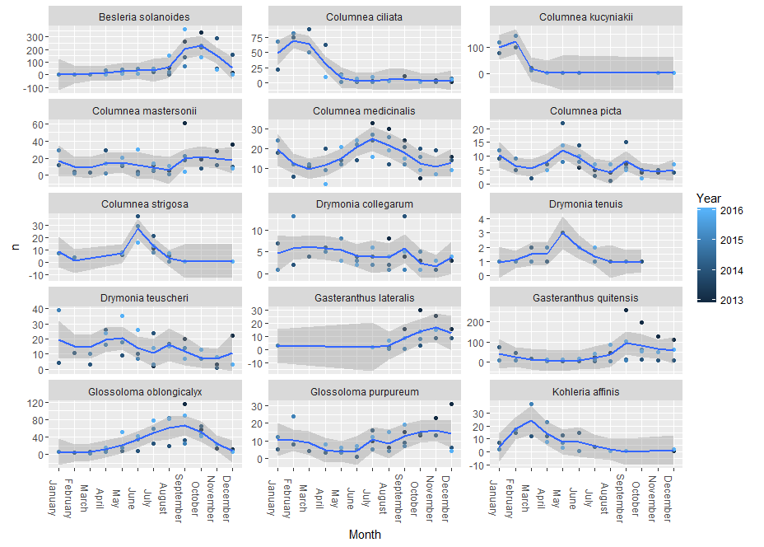

Eye-balling it and classifying plants into one of three seasons and those with no flowering seasonality - you get a pretty even split of flowering:

No “strong” pattern

*Columnea mastersonii (cinerea?)*

*Columnea picta*

*Drymonia collegarum*

*Drymonia teuscheri*

Jan – April

*Columnea ciliate*

*Columnea kucyniakii*

*Kohleria affinis*

May – Aug

*Columnea strigosa*

*Columnea medicinalis*

*Drymonia tenuis*

Aug – Dec

*Glossoloma oblongicalyx*

*Glossoloma purpureum*

*Besleria solanoides*

*Gasteranthus lateralis*

*Gasteranthus quitensis*

3. *Description of Gesneriaceae community morphological variation*: Uses data on plant species, plant traits, phylogeny.

PCA/ordination of flower traits to evaluate the major axis across which Gesneriaceae vary and potentially define flower syndroms within hummingbirds. Correlation between phylogenetic distance and trait similarity.

[Need to determine what the most informative traits are and if we want to do any trait-by-trait analyses based on hypotheses for specific traits.]

4. *Description of plant-hummingbird interactions*

Plant by bird interaction matrix (below, might not be needed)

PCA of plant use by hummingbirds (i.e., biplot below) – i.e., descriptive result of what hummingbirds use what plant species and also if related plants are used by similar hummingbird species (i.e., how close the plants are to each other in the ordination space).

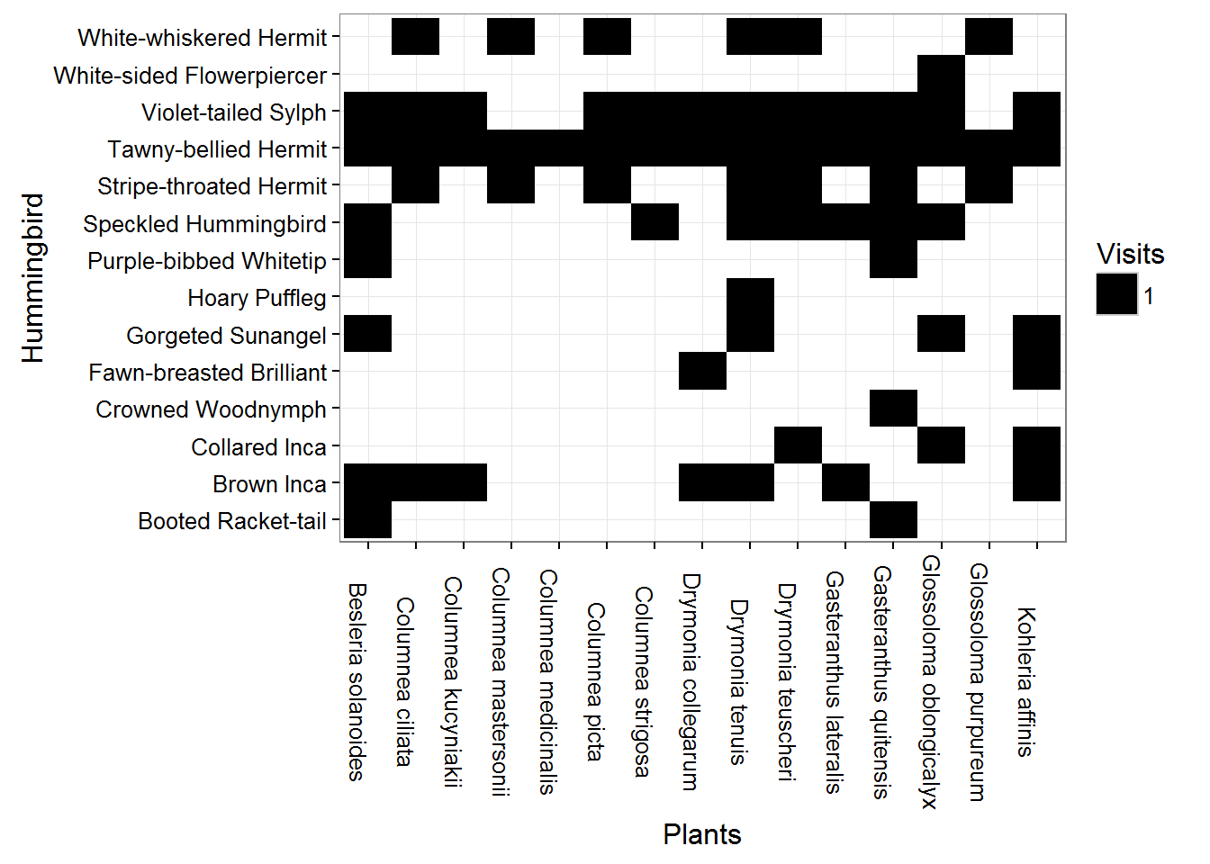

Hummingbird visitation (14 species)

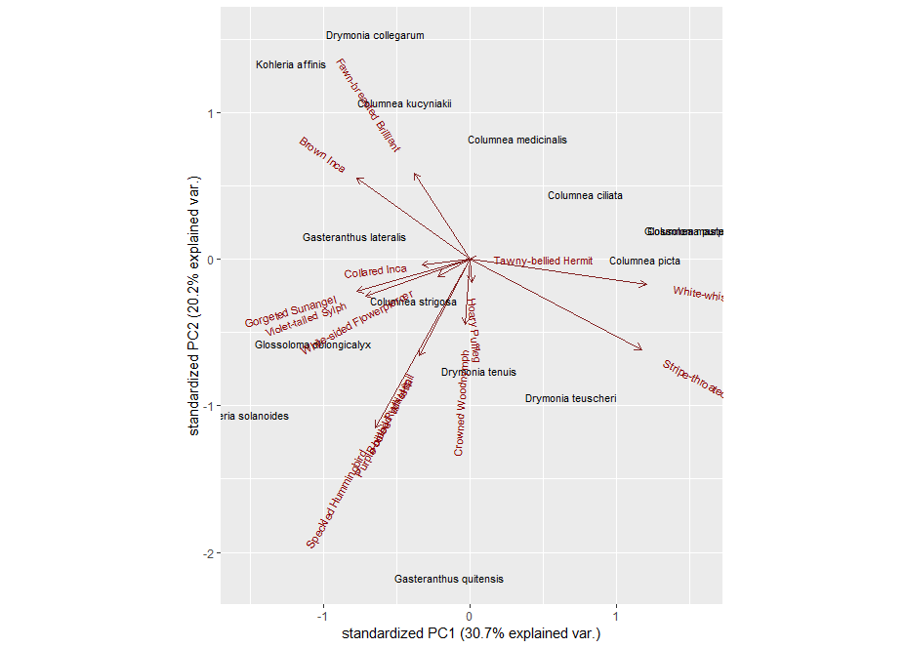

*Quantitative analyses to address H1*: Closely related plant species avoid pollinator competition by limiting temporal overlap in blooming; therefore, species that share hummingbird visitors bloom at different times of year.

Randomization tests for overlap of congeneric flowering species per month or phylogenetic distance and overlap of flowering.

*Quantitative analyses to address H2* [Closely related species that bloom at the same time have different hummingbird pollinators where differentiation in flower characteristics is related to reduced visitor overlap]:

Part 1 - Phylogenetic distance (branch lengths) and visitor overlap, along with a null model of visitor based on randomizing with respect to phylogeny [not sure that we need a plant by plant visitor distance matrix] - i.e., address the question are related plants visited by different species, should be maybe phylogenetic distance?

Part 2 - Mantel correlations between plant trait pca and visitor matrix – i.e., do plants with similar traits have similar visitors? Does this need to be done for seasons?

Note: To determine if species use related species but at different times of the year we need to define seasons.

Potential Analysis from Ben’s doc.

Fig 1. Plant by bird interaction matrix alongside plant by plant visitor distance matrix

Fig 2. Phylogenetic distance (branch lengths) and visitor overlap, along with a null model of visitor based on randomizing with respect to phylogeny.

Fig 3. Flower morphology and life history PCA

Fig 4. Phenology and timing of peak flowering

Fig 5. Randomization tests for overlap of congeneric flowering species per month

Table 1. Mantel correlations between trait pca and visitor matrix.